**What is Deep Learning ?**

Deep Learning is a subfield of A.I & M.L that is inspired by the structure of Human Brain.

Deep Learning Algorithms attempt to draw similar conclusion as humans would by continually analyzing data with given logical structure called Neural Network.

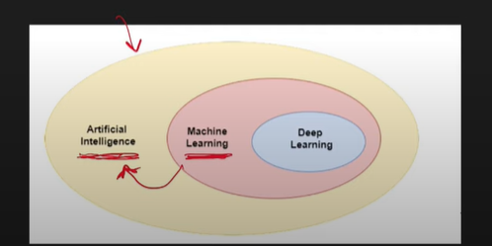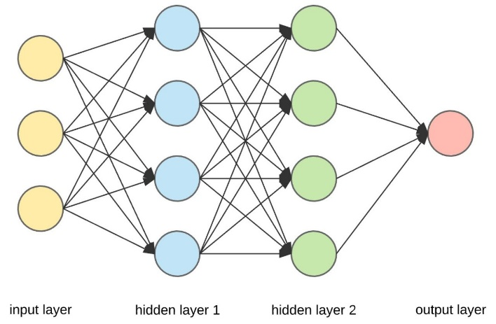

Circles are Perceptron

Arrows are Weights

& the line of perceptron are layer.

*Types of Neural Network 🡪*

**ANN (Artificial Neural Network)** – Simple vala

**CNN (Convolutional Neural Network)** – It works well on Image data

**RNN (Recurrent Neural Network)** -- It works well on Speech & Text Data

**GANN** – It generates things.

& Many More

ML & DL both approaches are different

ML uses statistical techniques & DL uses or replicated Human Brain

***Why is Deep Learning getting So Famous?***

***Reasons are as follow:***

1. ***Applicability***

*They are applicable in big domains it works for NLP, CV , Machine translation , Drug Design , Climate Science etc.*

1. ***Performance***

*Performance is such a great, Kuch scenarios mai human expert ka beat krdiya hai. State of Art performance deta hai .*

Deep Learning Algorithms uses multiple layers to progressively extract higher-level features from the raw input.

For e.g, in image processing, lower layers may identify edges, while higher layers may identify concepts to a human such as digits or letters or faces.

Deep Learning is part of a broader family of Machine Learning methods based on ANN with representation learning.

Representation Learning or Feature Learning:

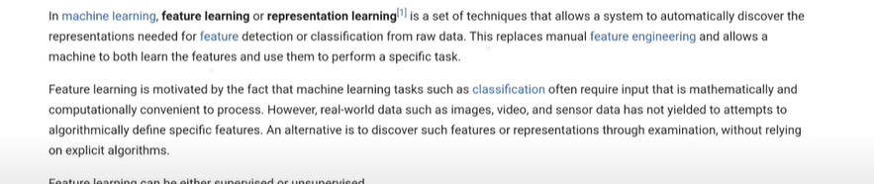

Feature Extraction or Feature Engineering -->

In this process we create features, in this we create features,

In ML we create Manual Features lyk Size 1 feature hai, color can be of feature etc.

In ML we have to create this features to give it to Algo

In DL this whole process is automated.

Automatic Feature Extractions.

In Deep Learning there is no requirement of Feature Engineering

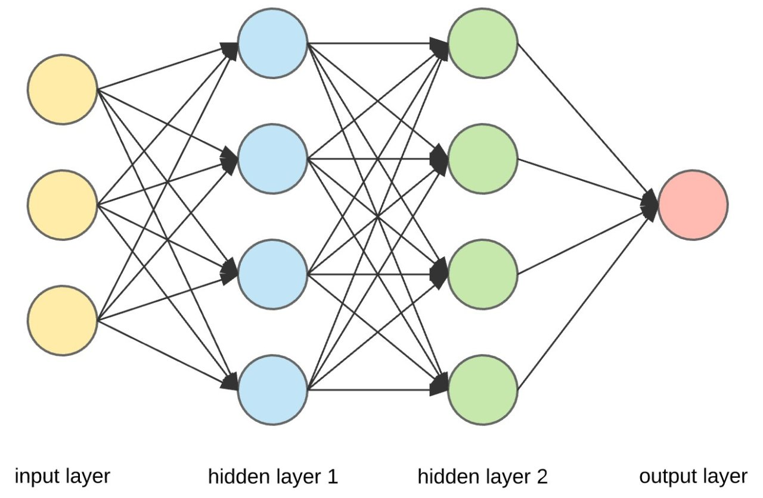

Deep Learning Algorithms uses multiple layers to progressively extract higher level features from the raw input,

For Example, in image processing, lower layers may identify edges, while higher layers may identify concept relevant to human such as digits or letters or faces.